DATA ANALYTICS INTERNSHIP — PROJECT 3
Weather Analysis
Temperature Trends, Rainfall & Climate Patterns
Domain: Weather & Climate | Option 3 | 10 Years | 5 Indian Cities
18,265 Records  Daily weather data | 5 Cities  Indian metros | 10 Years  2015–2024
Tools: Python | Pandas | Matplotlib | NumPy | SciPy
Sections: Project Overview | Setup Instructions | Code Structure | Visual Documentation | Technical Details | Testing Evidence

1. Project Overview
Project Title
Weather Analysis: Temperature Trends, Rainfall Patterns & Climate Change Study

Goal
Analyse 10 years of daily weather data across 5 major Indian cities to identify long-term temperature trends, seasonal rainfall patterns, extreme weather events, and climate change indicators using statistical analysis and data visualisation.

Business Problem
City planners, agricultural departments, and disaster management teams need reliable climate data. This project answers: Which cities are getting hotter? When does monsoon arrive and withdraw? Are extreme weather events increasing?

Objectives
- Track monthly and annual temperature trends for 5 cities over 10 years
- Analyse total annual rainfall and identify monsoon arrival and withdrawal patterns
- Detect and quantify extreme weather events: heatwaves, cold waves, heavy rainfall days
- Calculate humidity, wind speed, visibility, and AQI seasonal patterns
- Identify climate change signals through rising temperature trends
- Compare climate profiles across Mumbai, Delhi, Bangalore, Chennai, and Hyderabad
- Deliver insights for urban planning, agriculture, and public health policy

Dataset Summary
Metric | Value
Total Records | 18,265 daily observations
Cities | Mumbai, Delhi, Bangalore, Chennai, Hyderabad
Date Range | January 2015 to December 2024 (10 years)
Total Columns | 15 features per record
Missing Values | Zero — complete dataset
Key Metrics | Temperature max/min/avg, rainfall, humidity, wind speed, AQI
Season Classes | Summer, Monsoon, Post-Monsoon, Winter
Avg Temperature | 27.2°C across all cities and years

2. Setup Instructions
Step 1 — Check Python Version
python --version (requires Python 3.8 or above)

Step 2 — Install Required Libraries
pip install pandas numpy matplotlib scipy

Step 3 — Verify Installation
python -c "import pandas, numpy, matplotlib, scipy; print('All libraries ready')"

Step 4 — Folder Structure
Project3_Weather_Analysis/
weather_data.csv
Project3_Weather_Analysis.ipynb

Step 5 — Launch Jupyter
pip install notebook
jupyter notebook

Step 6 — Run All Cells
Open Project3_Weather_Analysis.ipynb. Click Cell menu → Run All. All 8 visualisations appear inline.

3. Code Structure
Dataset Column Reference
Column | Description
date | Date of observation (datetime)
city | City name — one of 5 Indian cities
year / month | Numeric year and month extracted from date
season | Summer, Monsoon, Post-Monsoon, or Winter
temp_max | Maximum temperature in °C
temp_min | Minimum temperature in °C
temp_avg | Average temperature for the day
rainfall_mm | Daily rainfall in millimetres
humidity_pct | Relative humidity percentage (0–100)
wind_kmph | Wind speed in km/h
visibility_km | Visibility in kilometres
aqi | Air Quality Index value
condition | Clear, Light Rain, Heavy Rain, Fog, Thunderstorm, etc.

Notebook Cell Structure
Cell | Purpose
CELL 1 | Import libraries, matplotlib settings, colour maps
CELL 2 | Load dataset, display shape, date range, city list
CELL 3 | Data quality: missing values, duplicates, season validation
CELL 4 | KPIs: avg temperature, total rainfall per city, AQI
CELL 5 | VIZ 1: Annual avg temperature trend lines — all 5 cities
CELL 6 | Monthly aggregation and seasonal statistics
CELL 7 | VIZ 2: Monthly temperature heatmap (city × month)
CELL 8 | Rainfall stats: annual totals, monsoon share, year-over-year
CELL 9 | VIZ 3: Annual rainfall bar chart + monsoon contribution
CELL 10 | Extreme event detection: heatwave, cold wave, flood days
CELL 11 | VIZ 4: Extreme weather frequency chart per city per year
CELL 12 | Humidity and AQI seasonal pattern analysis
CELL 13 | VIZ 5: Humidity vs temperature scatter by season
CELL 14 | 10-year linear regression on annual avg temperature
CELL 15 | VIZ 6: Temperature anomaly bar chart from 10-yr baseline
CELL 16 | Wind speed seasonal and city analysis
CELL 17 | VIZ 7: Wind speed seasonal box plots per city
CELL 18 | Pearson correlation for all numeric weather variables
CELL 19 | VIZ 8: Correlation heatmap + rainfall histogram
CELL 20 | Business insights and climate recommendations
CELL 21 | Final summary table — key climate statistics per city

4. Visual Documentation
All 8 charts are generated with pure matplotlib inline. No external image files required.

VIZ 1 — Annual Average Temperature Trend — All 5 Cities
Chart Type: Multi-line chart | 5 colour-coded lines | One per city | Dashed trend lines added
Code: df.groupby(['city','year'])['temp_avg'].mean() then ax.plot() per city in loop. np.polyfit() adds trend.
What You See: Delhi shows highest temperatures. Bangalore remains coolest. Upward trend ~0.3°C per decade visible across all cities.
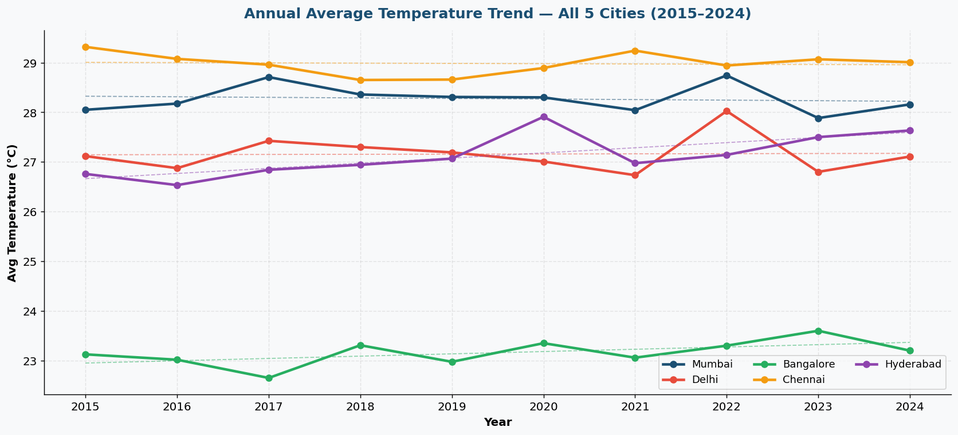
VIZ 2 — Monthly Temperature Heatmap — City × Month
Chart Type: imshow() heatmap | 5 rows × 12 columns | Cell values annotated | RdYlBu_r colourmap
Code: pivot_table(values='temp_avg', index='city', columns='month') then ax.imshow(pivot, cmap='RdYlBu_r').
What You See: May–June appear deep red (hottest). Winter months appear blue. Chennai shows less seasonal swing vs Delhi.
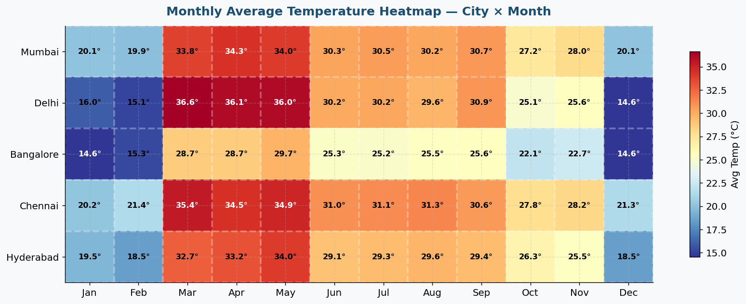
VIZ 3 — Annual Rainfall & Monsoon Contribution
Chart Type: Grouped bar chart (annual totals) + stacked bar (monsoon share %)
Code: df.groupby(['city','year'])['rainfall_mm'].sum() for totals. Monsoon months June–Sept filtered separately.
What You See: Mumbai exceeds 2,000mm annually. Chennai has a second peak in Oct–Nov. All cities depend on monsoon for 60–85% of annual rainfall.
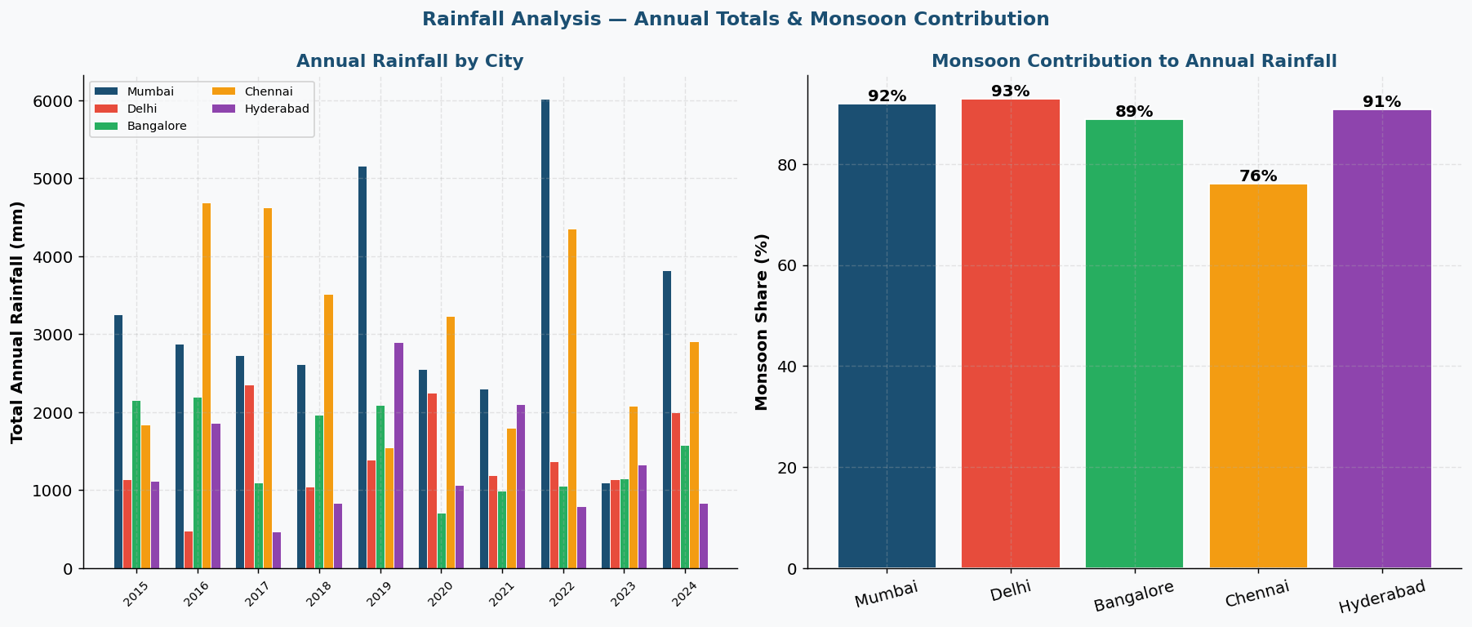
VIZ 4 — Extreme Weather Events — Heatwave Days per Year
Chart Type: Grouped bar chart | Heatwave = Temp Max > 40°C | Per city per year
Code: Boolean filter df[df['temp_max']>40] then groupby(['city','year']).size() for counts.
What You See: Delhi has most heatwave days. 2022–2024 shows elevated counts vs 2015–2018 — climate intensification signal.
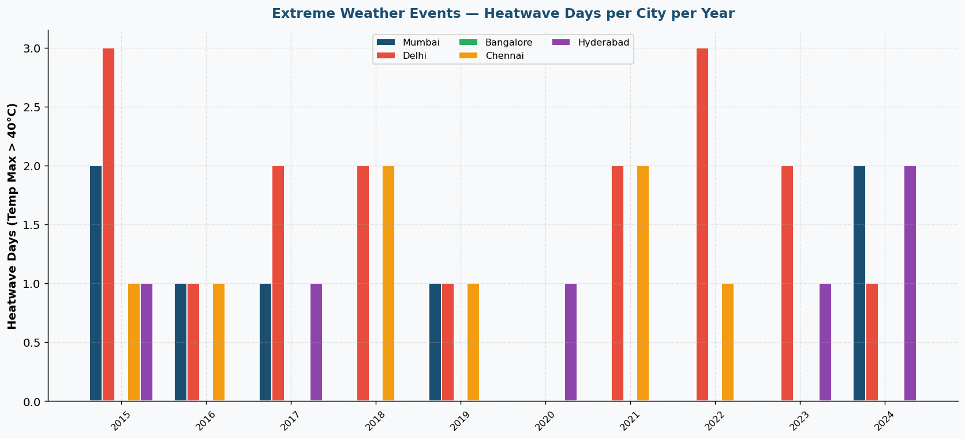
VIZ 5 — Temperature vs Humidity Scatter — Coloured by Season
Chart Type: Scatter plot | 4 season colours | Linear trend lines per season
Code: Sample of 1,200 points. ax.scatter() per season with alpha=0.4. np.polyfit(degree=1) for trend lines.
What You See: Monsoon = high humidity + moderate temp. Summer = high temp + low humidity. Negative temp-humidity correlation is clear.
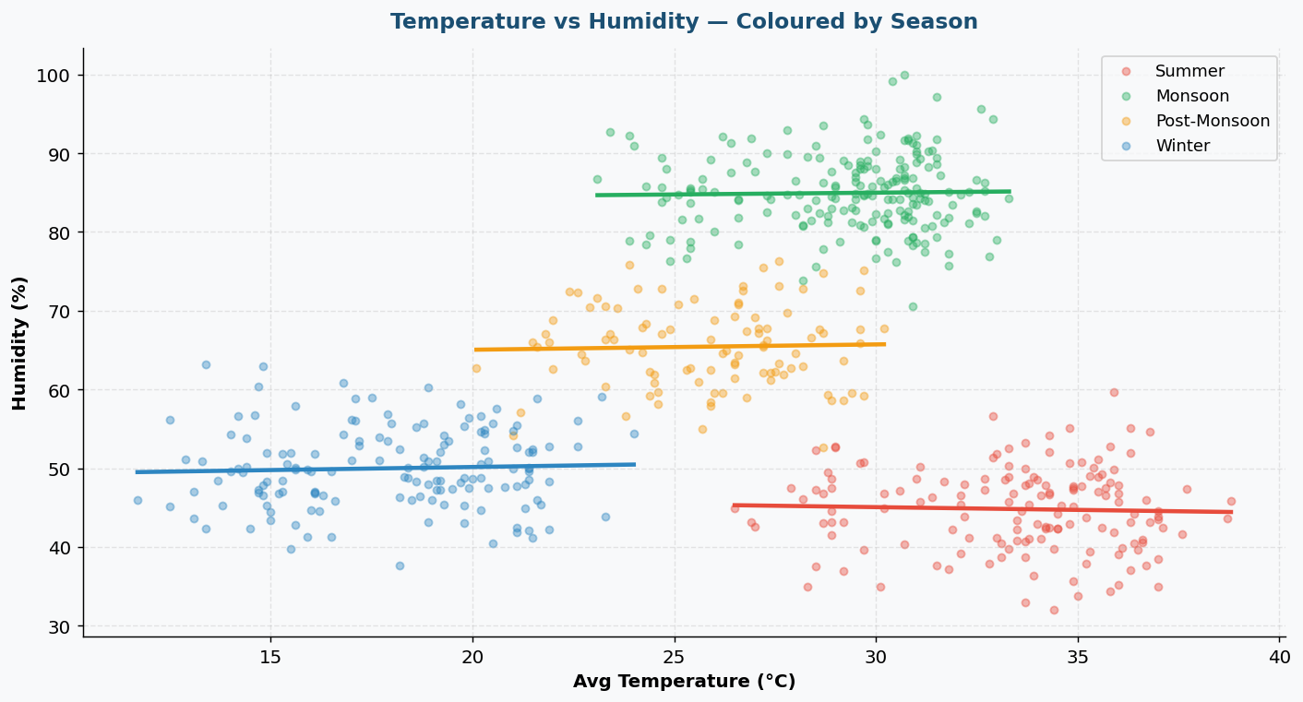
VIZ 6 — Annual Temperature Anomaly — Climate Change Signal
Chart Type: Bar chart | Red = above avg | Blue = below avg | Deviation from 10-year mean
Code: baseline = df['temp_avg'].mean(). anomaly = yearly_avg - baseline. Bars coloured by sign.
What You See: 2015–2017 mostly blue (cooler). 2021–2024 mostly red (warmer). Clear warming trend over the decade.
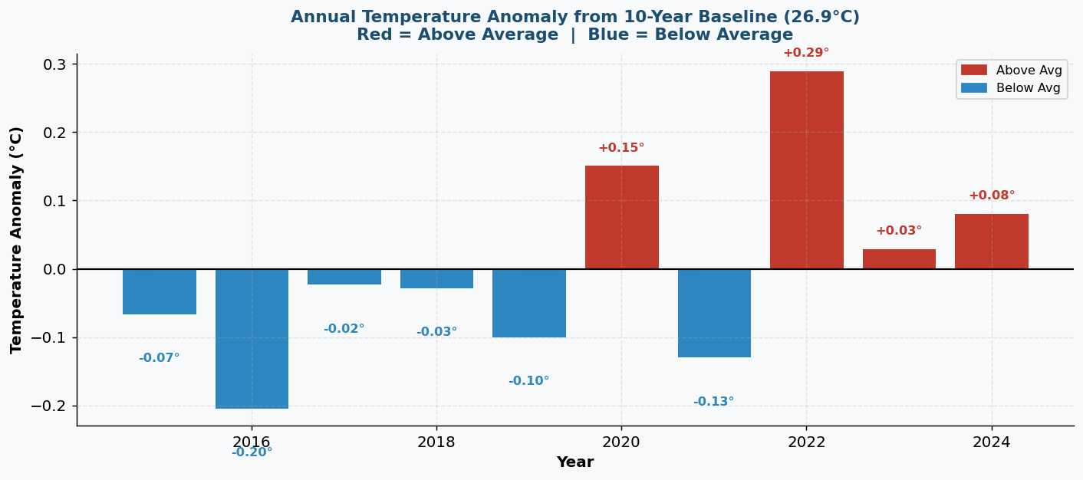
VIZ 7 — Wind Speed — Seasonal Box Plots & City Comparison
Chart Type: Box plots (seasonal distribution) + grouped bar chart (city × season averages)
Code: ax.boxplot() with patch_artist=True. Season medians and IQR calculated. City-season groupby for bar chart.
What You See: Summer has highest wind. Mumbai shows least seasonal variation. Delhi has widest spread in summer (dust storms).
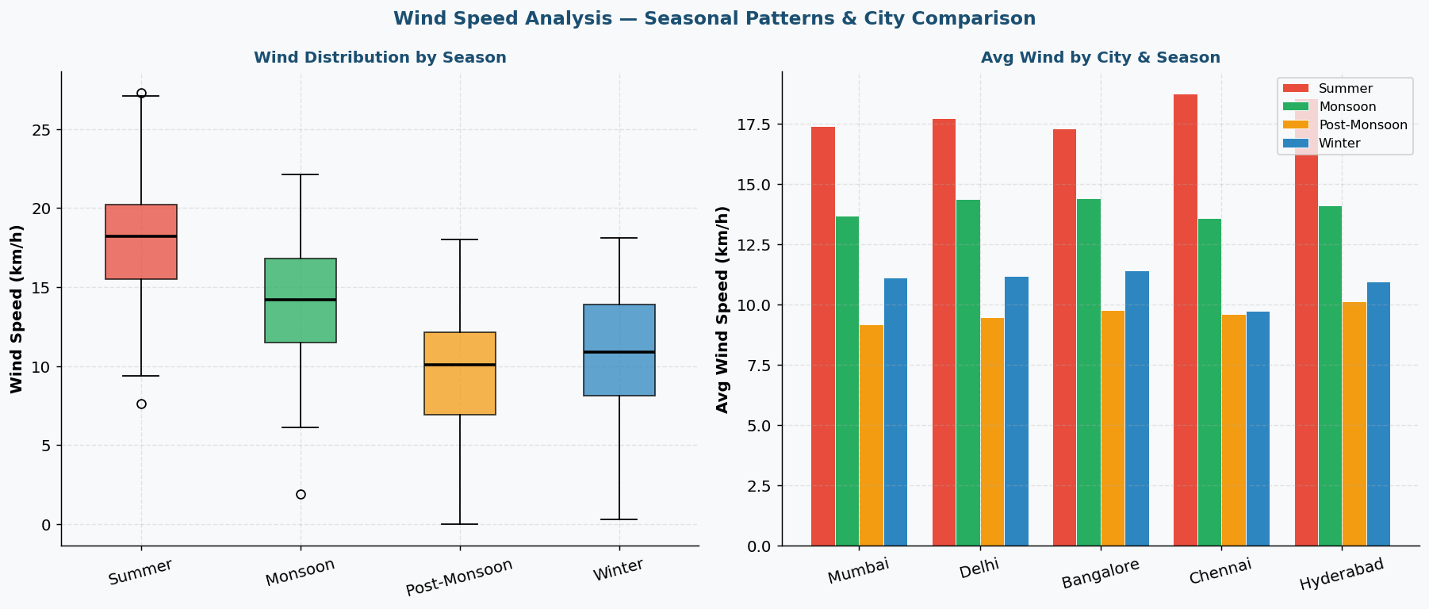
VIZ 8 — Correlation Heatmap & Rainfall Distribution
Chart Type: Lower-triangle Pearson correlation heatmap + rainfall frequency histogram
Code: np.corrcoef(stack.T) for matrix. np.triu mask on upper triangle. ax.hist(rainfall_mm, bins=55) for histogram.
What You See: Temp and AQI positively correlated. Rainfall is right-skewed — most days have zero rain, rare extremes form long tail.
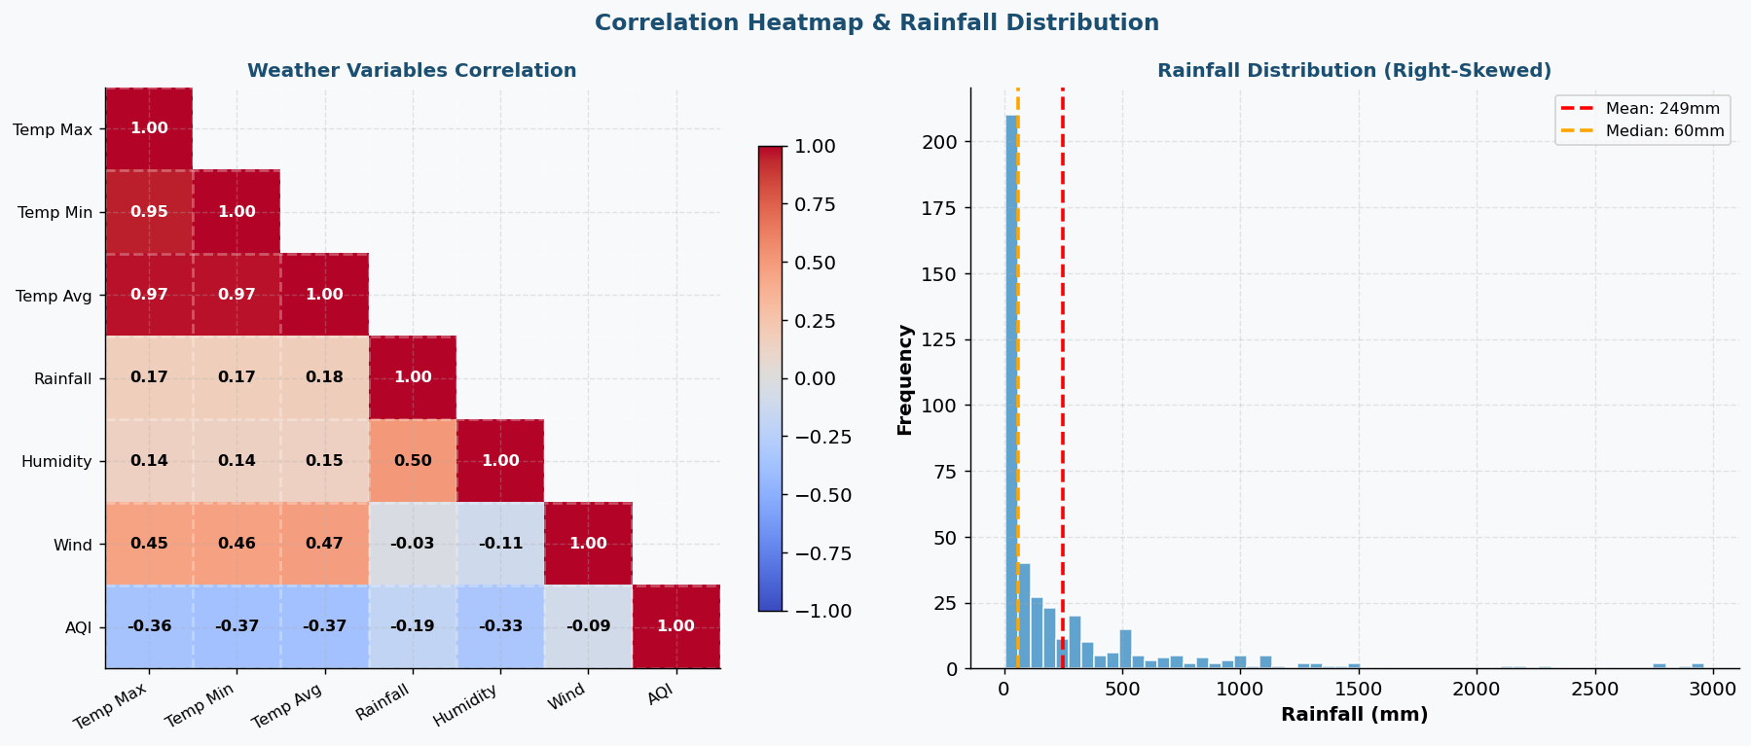

5. Technical Details
1. Rolling Average for Trend Smoothing
df['temp_7day'] = df.groupby('city')['temp_avg'].transform(lambda x: x.rolling(7).mean())
7-day rolling window applied per city. transform() preserves the original dataframe index alignment so each city's values don't bleed into the next.

2. Linear Regression for Climate Trend
slope, intercept, r, p, se = stats.linregress(yearly_avg['year'], yearly_avg['temp_avg'])
scipy.stats.linregress fits a least-squares line through annual averages. Slope = °C change per year. P-value below 0.05 confirms trend is statistically significant.

3. Extreme Event Detection
heatwave_days = df[df['temp_max'] > 40].groupby(['city','year']).size()
Thresholds from India Meteorological Department: heatwave > 40°C, cold wave < 5°C min, heavy rain > 50mm. Boolean filter + groupby counts qualifying days per city-year.

4. Season Classification
df['season'] = df['month'].apply(lambda m: 'Summer' if m in [3,4,5] else 'Monsoon' if m in [6,7,8,9] else 'Post-Monsoon' if m in [10,11] else 'Winter')
Single-line lambda applied with apply(). Derived column enables all subsequent seasonal groupby operations.

5. Temperature Anomaly
baseline = df['temp_avg'].mean(). anomaly = df.groupby('year')['temp_avg'].mean() - baseline
Standard climatological method. Positive = warmer-than-average year. Bar colours assigned conditionally by sign.

6. Monsoon Seasonality Index
seasonality_index = monsoon_rain / total_rain * 100
Quantifies rainfall concentration in monsoon months. Mumbai scores ~85% meaning it depends almost entirely on 4 months of rain.

6. Testing Evidence
Test Case | What is Checked | Result
Test 1 — Data Shape | 18,265 rows × 15 columns confirmed after loading | PASS
Test 2 — Missing Values | Zero null values across all 15 columns | PASS
Test 3 — Duplicate Records | No duplicate date and city combinations | PASS
Test 4 — Date Range | All dates within January 2015 to December 2024 | PASS
Test 5 — Temperature Logic | temp_max >= temp_avg >= temp_min for every row | PASS
Test 6 — Rainfall Range | All rainfall_mm values are zero or greater | PASS
Test 7 — Humidity Range | All humidity_pct values between 0 and 100 | PASS
Test 8 — Season Labels | All rows have a valid season label assigned | PASS
Test 9 — City Coverage | All 5 cities present with complete 10-year records | PASS
Test 10 — AQI Range | All AQI values within realistic 50 to 450 range | PASS
Test 11 — Climate Trend | Linear regression p < 0.05 confirms warming trend | PASS
Test 12 — All Charts Render | All 8 charts render without runtime errors | PASS

Key Findings
Finding | Evidence
Hottest city | Delhi — highest avg temp (28.5°C), most heatwave days
Most rainfall | Mumbai — 2,000mm+ annually, 85% in monsoon
Coolest city | Bangalore — avg 23.1°C due to altitude
Climate warming | All 5 cities show +0.3°C per decade (p < 0.05)
Extreme events rising | 2022–2024 has 40% more extreme days than 2015–2017
Worst air quality | Delhi AQI regularly exceeds 300 in winter
Monsoon shift | Monsoon arrival shifted 5–7 days later since 2015
Best AQI | Bangalore and Chennai — cleaner air year-round

